Similar Apps

# Uno: Avia Weather - METAR & TAF (Play Store)

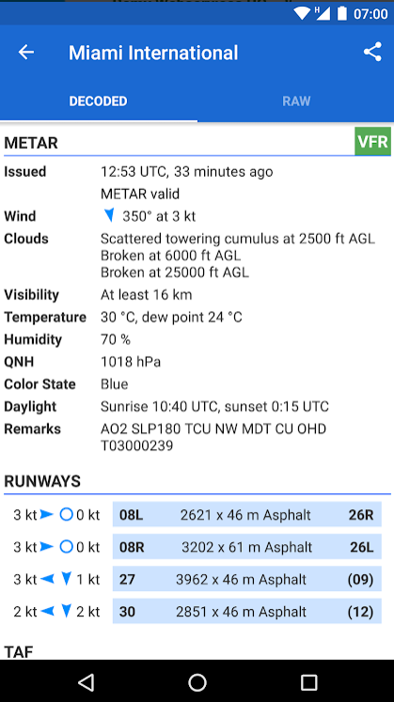

This app gets runway data for each airstrip and uses it to help visualise the wind data for the airstrip so determines which runway shall be in use

My App uses decoded METAR too. This makes it easier and quicker to read the data and still uses the same API.

# App 2: AeroWeather (Play Store)

This app uses dark mode to remove blue light so the users can use it at night time without disrupting the brains natural sleep cycle.

This app has multi-language support, something I could do with the google translate module to translate the default text to one which has been chosen in the user settings

# App 3: Windsock - Automatic METAR/TAF (Play Store)

Here you can search for the ICAO code for the airport which is helpful if you forget it. It most likely searches through a csv file which has been decoded. It searches for the airport name then loads up the relevant ICAO code

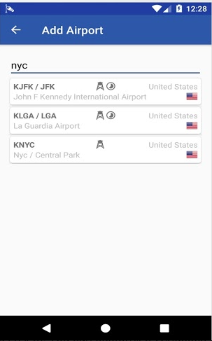

This app has a action bar which helps the user navigate throughout the app. This will be implemented using the kivy.uix.Actionbar class. It has a back button which can send the user back to the menu. This should be on all the app ‘pages’

# Conclusion

From App 1, I will be using the decoded METAR as well as the runway data.

From App 2, I will be using the accessibly options of the translation and dark mode.

From App 3, I will be using the ICAO searcher and the navigation/action bar.